Seed Bag:
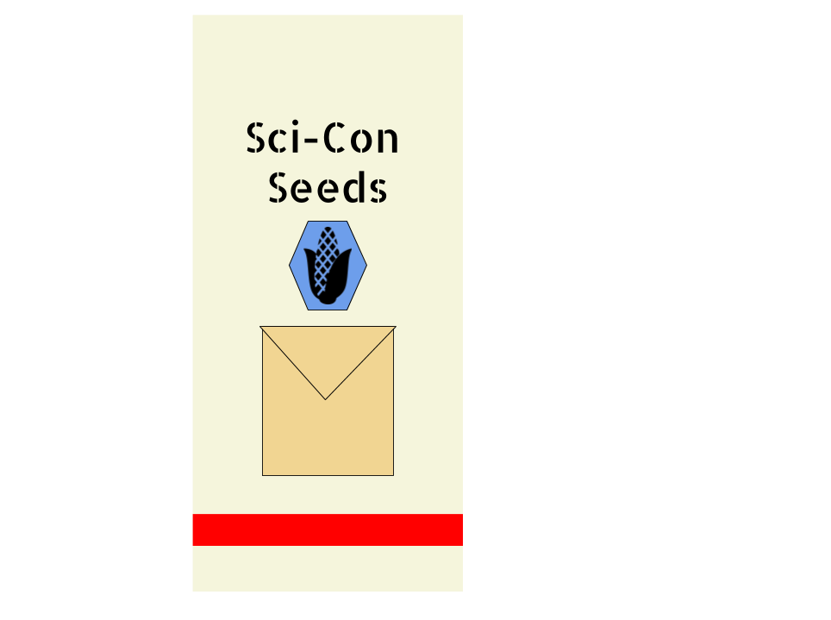
Size:
- Envelope: 8.5 inches x 11 inches
- Bag: 48 inches x 20 inches x 5 inches
Materials:
- 8.5 by 11 manilla folder
- 50 pounds of modified seeds (either corn or soybeans)
- 48 inches x 20 inches x 5 inches canvas bag
Angles: All corners for the bag and envelope are 90 degrees, can change due to stretching.

Instructions:
Instruction Packet
Size
- 8.5” x 11”
- 5 Pages
Materiels
- Paper
- Printer Ink
All angles are 90 degrees.

